

**School of Engineering and Applied Science,**

**Ahmedabad University**

**CSE300 Software Engineering**

**Weekly Report**

**Guided By: Prof Khushru Doctor**

**TA Muskan Matwani**

**TA Anupama Nair**

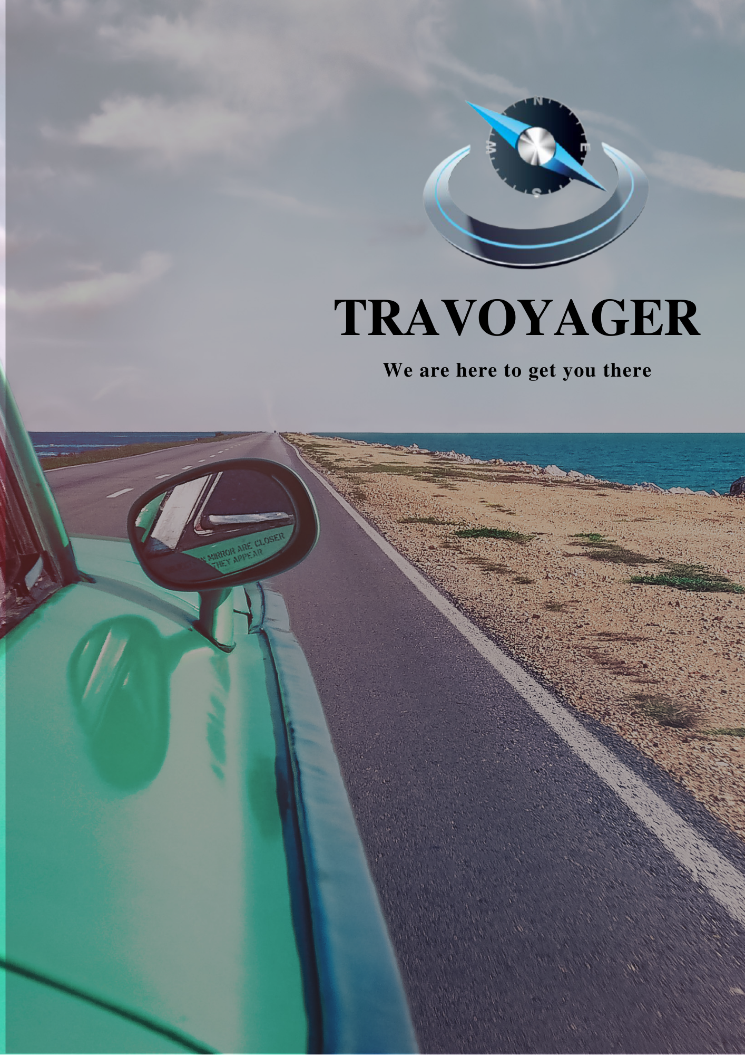

**WEEKLY MEETING REPORT - 0**

**Agenda** - Formal Introduction and Brainstorming for Topic Selection

**Date and Time**

**________________________________________________________________________________________________________________________________________________________________________________________________________________________________________________________________________________________________________________________________________________________________________________________________________________________________**

February 2, 2021 3:00-4:00P.M.

**Location**

**________________________________________________________________________________________________________________________________________________________________________________________________________________________________________________________________________________________________________________________________________________________________________________________________________________________________**

Google Meet

**Schedule**

**________________________________________________________________________________________________________________________________________________________________________________________________________________________________________________________________________________________________________________________________________________________________________________________________________________________________**

|  |  |
| --- | --- |
| **Time** | **Description** |
| 3:00-3:05 P.M. | Attendance |
| 3:05-3:15 P.M. | Introduction of team members |
| 3:15-3:25 P.M. | Technical skills discussion on an individual basis |
| 3:25-4:15 P.M. | Topics suggestion and discussion |
| 4:15-4:20 P.M. | Summary |
| 4:20 P.M. | Meeting adjourned |

**Details**

**________________________________________________________________________________________________________________________________________________________________________________________________________________________________________________________________________________________________________________________________________________________________________________________________________________________________**

* Topics Discussed
  + Online Shopping System
  + Hotel Management System
  + Inventory Management System
  + Online Food Ordering
  + Online School Portal
  + Task Scheduling System
  + Travel Recommendation System
  + Stock Market Prediction System

**Conclusion**

**________________________________________________________________________________________________________________________________________________________________________________________________________________________________________________________________________________________________________________________________________________________________________________________________________________________________**

Brief thinking about all ideas and selecting one by every individual by next meeting

**Next Meeting Details**

**________________________________________________________________________________________________________________________________________________________________________________________________________________________________________________________________________________________________________________________________________________________________________________________________________________________________**

February 3, 2021 4:00-5:00P.M.

**Next Agenda**

**________________________________________________________________________________________________________________________________________________________________________________________________________________________________________________________________________________________________________________________________________________________________________________________________________________________________**

Topic selection and model selection